
Prayer and worship at home
Friday 10th April, 2020
Good Friday

If a household are praying together, one person may act as leader and the others as the congregation and they join in the words in bold type.
If alone, read all the words aloud.
You may want to have a cross or crucifix to look at.
You might prepare for this act of worship by listening to some music, or by being still
Preparation

You may wish to begin with an extended time of silence

Today’s prayer
Eternal God,
in the cross of Jesus
we see the cost of sin
and the depth of your love:
in humble hope and fear
may we place at his feet
all that we have and all that we are,
through Jesus Christ our Lord.
Amen.

The Word of the Lord

FIRST READING: Lamentations 5.15-end
¹⁵ The joy of our hearts has ceased;
our dancing has been turned to mourning.
¹⁶ The crown has fallen from our head;
woe to us, for we have sinned!
¹⁷ Because of this our hearts are sick,
because of these things our eyes have grown dim:
¹⁸ because of Mount Zion, which lies desolate;
jackals prowl over it.
¹⁹ But you, O Lord, reign for ever;
your throne endures to all generations.
²⁰ Why have you forgotten us completely?
Why have you forsaken us these many days?
²¹ Restore us to yourself, O Lord, that we may be restored;
renew our days as of old—
²² unless you have utterly rejected us,
and are angry with us beyond measure.
This is the word of the Lord.
Thanks be to God.

(you may also wish to read Psalm 22)

The Passion of the Lord

St. John’s Gospel, chapters 18 & 19 are read.

Reflecting on the Cross

You may want to spend some moments in silence looking at a cross. Give thanks that Jesus died for us, and for our salvation…

We adore you, O Christ, and we bless you,
Because by your holy cross you have redeemed the world.

This is the wood of the cross, on which hung the Saviour of the world.
Come, let us worship.

O Saviour of the world,
who by your cross and precious blood have redeemed us,
save us and help us, we humbly pray.

Prayers of intercession
(Here you may wish to offer prayer in your own words,
or be prompted by the words here)

We pray for the Church of God throughout the world: for the Diocese of Blackburn and for Julian, Philip and Jill our bishops… we pray for those who are mocked or persecuted for their faith…

We pray for those who do not believe the gospel of Christ, for those who are enemies of Christ and persecute those who follow him, for all who deny the faith of Christ crucified…

We pray for all living with the coronavirus…

We pray for the health and well-being of our nation, for Elizabeth our Queen; our Prime Minister and Government…

We pray for our NHS, for the isolated and housebound, that we may be alert to their needs,
and care for them in their vulnerability…

We pray for all who suffer in body, mind or spirit… we pray for all prisoners, captives and refugees… we pray for all at the point of death and those who watch beside them…

We remember those who have died in recent days, and all whom we love but see no longer…

After a period of silent prayer:
Holy God,
holy and strong,
holy and immortal,
have mercy upon us.

The Lord’s Prayer

Standing at the foot of the cross, as our Saviour taught us so we pray:
Our Father, who art in heaven…
(or)
Our Father in heaven…

Concluding Prayers

Almighty Father,
look with mercy on this your family
for which our Lord Jesus Christ was content to be betrayed
and given up into the hands of sinners
and to suffer death upon the cross;
who is alive and glorified with you and the Holy Spirit,
one God, now and for ever. Amen.

O Lord Jesus Christ,
Son of the living God,
set your passion, cross and death
between your judgement and our souls,
now and in the hour of our death.
Grant mercy and grace to the living,
rest to the departed,
to your Church peace and concord
and to us sinners forgiveness,
and everlasting life and glory;
for, with the Father and the Holy Spirit,
you are alive and reign,
God, now and for ever. Amen

Late evening prayer

You may wish to use this provision before going to bed.

Psalm 88

Jesus dies on the Cross –
a sonnet by Malcolm Guite.

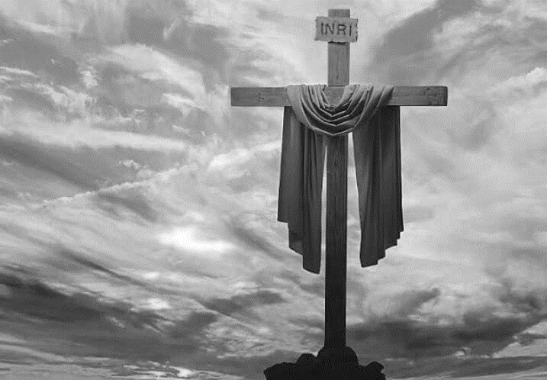

The dark nails pierce him and the sky turns black
We watch him as he labours to draw breath
He takes our breath away to give it back,
Return it to it’s birth through his slow death.
We hear him struggle breathing through the pain
Who once breathed out his spirit on the deep,
Who formed us when he mixed the dust with rain
And drew us into consciousness from sleep.
His spirit and his life he breathes in all
Mantles his world in his one atmosphere
And now he comes to breathe beneath the pall
Of our pollutions, draw our injured air
To cleanse it and renew. His final breath
Breathes us and bears us through the gates of death.

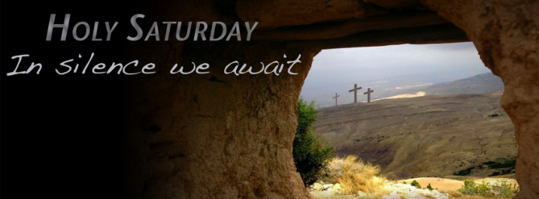
Readings and prayer for Holy Saturday
Job 14:1-14
Matthew 27:57-end

In the depths of our isolation
we cry to you, Lord God:
give light to our darkness
and bring us out of the prison of our despair.
through Jesus Christ our Lord. Amen

