Managing Covid Symptoms
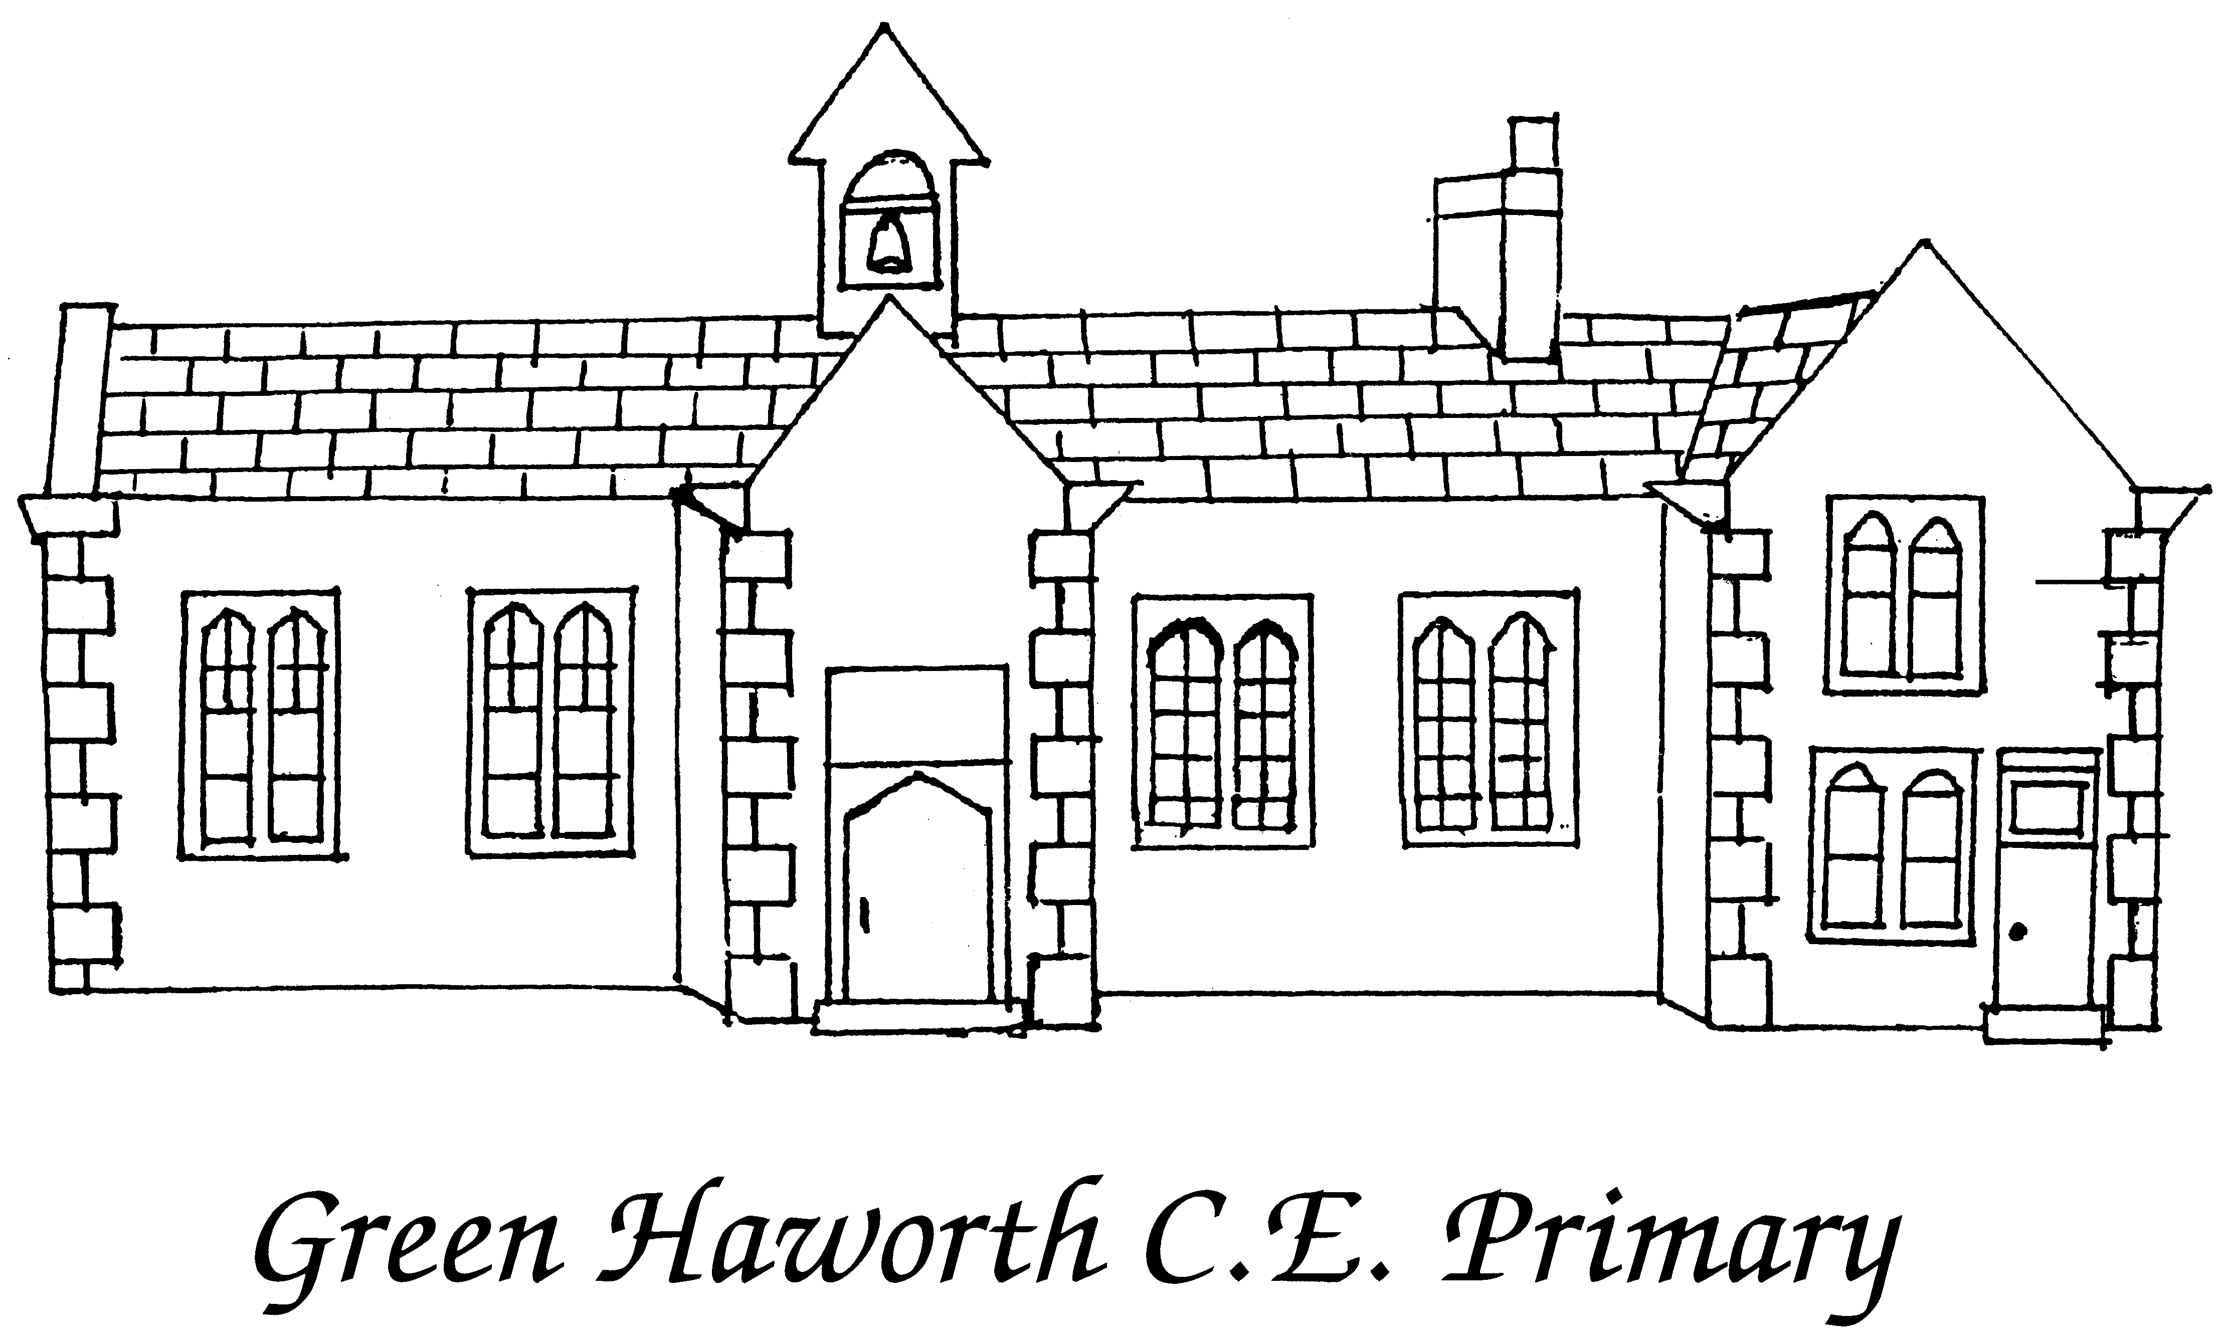
If your child shows any COVID-19 symptoms, they cannot return to school without receiving a negative test.
POSITIVE
If you are contacted by NHS Test and Trace (and your child was with you during your contact with the COVID 19 person), you and your child must self-isolate for 14 days even if you receive a negative test result.
Child stays at home for 10 days
If child is well and temperature has gone…..
Child must stay at home for at least 10 days and until temperature has gone.
Member of your household showing symptoms must get COVID TEST -
Covid NHS Tel. No. 119 and others get tested if they show symptoms.
School must be notified of result.
NEGATIVE
POSITIVE
NEGATIVE
All members of the household must stay at home.
CHILD MUST GET A COVID TEST
Covid NHS Tel. No. 119
School must be notified of result.
Child must stay at home.
YES
YES
Your child can go to school
NO
Does your child have a temperature, new continuous cough or lost sense of taste/smell?
Does any member of your household have a temperature, new continuous cough or lost sense of taste/smell?

