
COASTAL REGIONS
KNOWLEDGE ORGANISER
Overview |  |  | Features of Coastal Regions |  |  |  |  | Key Vocabulary  Coast  Region  Ocean  Tide  Beach  Longshore Drift  Erosion  Lighthouse  Cove  Headland  Formation  Rocks  Pebbles  Sand
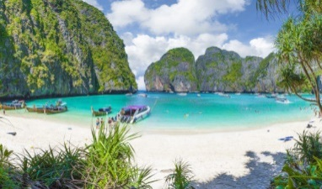  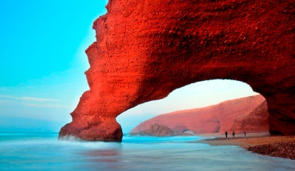  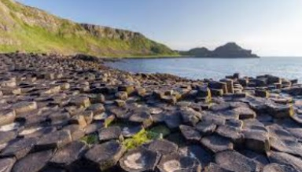  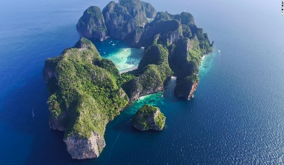  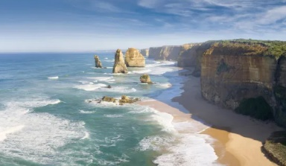  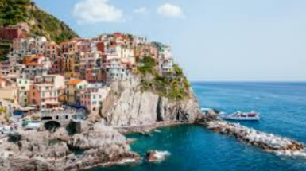  -Coastal regions are areas of the Earth where land meets the sea.  -Costal habitats are widely diverse, from shallow sea water, to dunes and beaches, to rock pools and coves.  -These are formed in different ways and support a wide variety of life forms.  -Tides are caused by the gravitational pull of the Sun and the Moon.  -Coastal erosion is the gradual wearing away of coastal land by the sea, ice and the wind. This means that coasts are always changing. |  |  | Erosion | 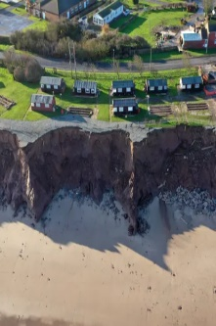 | -Water wind and ice can cause erosion.  -Erosion is the wearing away of the rock and soil. The repeated force of the waves crashing against the rocks causes pieces to fall off.  -Water that gets trapped in small cracks can also freeze in cold weather. When ice melts in warmer weather, it expands, breaking apart the rocks.  -Plants, animals and humans can also cause erosion, e.g. by building (humans) and grazing (animals).
 |  |  | Longshore Drift | 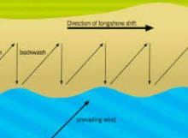 | -Longshore drift is where particles of soil and clay are transported in sea currents. Where the soil and clay are deposited down the coast, they create new land. Groynes and sea walls can prevent this happening.
 |  |  | Coastal Wildlife | 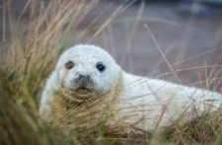  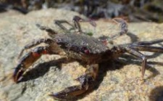  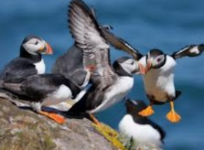 | -Coastal regions contain a wide variety of lifeforms that have evolved to live in the unique conditions.  -Sea birds often roost in coastal areas, and the nests of many birds can be found along rocky shores.  -Some larger birds, e.g. peregrine falcons, build their nests on cliff faces. Some creatures live in water left in rockpools, e.g. some types of crabs.  -Seals often live on sea rocks, as it gives them easy access to the sea, where they can catch fish.  -Sandy beaches provide the perfect habitat for lug  worms to live beneath the surface.  -Sea urchins are often found in the shallow sea.
Types and Zones of Coastal Landscapes
Types of Coastal Landscapes  -Coastal landscapes can vary dramatically, from calm, sheltered coves and sandy/rocky beaches to tall, rocky cliffs that are battered by ocean waves.  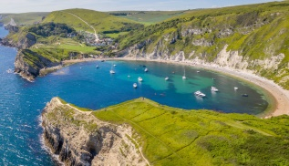  -Coves are a small type of bay or coastal inlet. Coves usually have narrow, restricted entrances, are often circular or oval, and are often situated within a larger bay. Coves are formed when water, wind and ice erode softer rock, leaving behind harder rock.  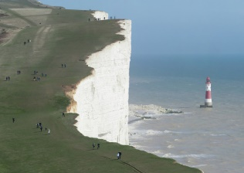  -Headland is a point of land around the coast where there is a high, sheer drop directly towards the water (e.g. cliffs). A headland of large size is known as a cape. Headlands are formed when the sea repeatedly strikes a section of coast with bands of hard and soft rock. The bands of soft rock, such as sand and clay, erode more quickly than those of more resistant rock, such as chalk. This leaves a section of land jutting out into the sea. | Zones of Coastal Landscapes  -Coastal landscapes are often divided into several areas or ‘zones’, which are based on their position in relation to the tide.  -The sublittoral zone is the area that always lies below water, even at low tide. Because it is always underwater, the sublittoral zone is a stable habitat and has lots of wildlife, e.g. sea urchins and sponges.  -The intertidal zone is the area between the high and low tide lines. This means that it is sometimes underwater and sometimes above water. Any creatures living in this zone need to be adapted to live both in and out of water, e.g. mussels and crabs.  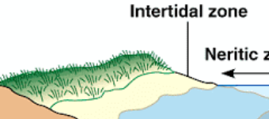  -The splash zone is the area above the tide line, which is never underwater (although it may be splashed by waves etc.) As this is a harsh environment, not many creatures can survive here.  Splash zone  Sublittoral zone |  | Coastal Wildlife
 |  |  | Threatened Coast | 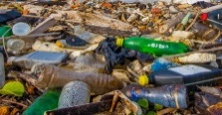 | -Scientists believe that global warming is causing sea levels to rise. Coastlines are also being threatened by marine pollution and damage from litter and waste.
 |  |  | Interesting Facts
 |  |  | - In the UK, nobody lives more than 80 miles from the coast.  - Many coastal animals have evolved with shells, to protect them from the battering sea and wind.  - Erosion can have benefits – it can help to uncover fossils.  - Coastlines make up around 8% of all land on Earth.  - However, they contain about 26% of all of the biological diversity on the planet. |  |  | - Over millions of years, coastlines have been affected by volcanic activity, ice ages, sea level changes.  - Coastal communities started as people lived by the sea, so that they could trade overseas.  - Many historical battles have taken place near the coast, as foreign invaders often came by boat.  - For this reason, there are many castles and forts near coasts.  - The UK coastline is 6,000km long!

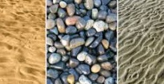

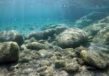
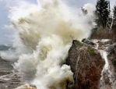
The type of beach depends on the types of rocks in the cliff from the beginning.
Eventually, they become tiny grains of sand, which are deposited by the sea to form a beach.
These rocks are tossed about by the sea, which breaks them down into smaller and smaller pebbles.
When waves batter against cliffs, they cause erosion. Large rocks fall from the cliff to the sea.
How Beaches are Formed

