RE
Tuesday 2nd March
Joy
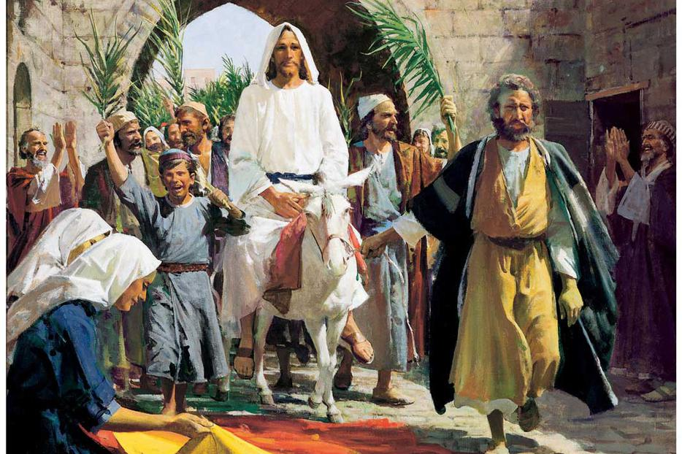
Sadness
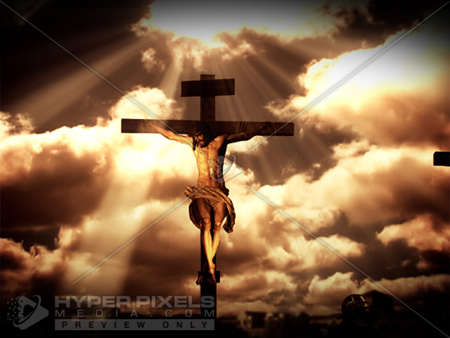

Joy
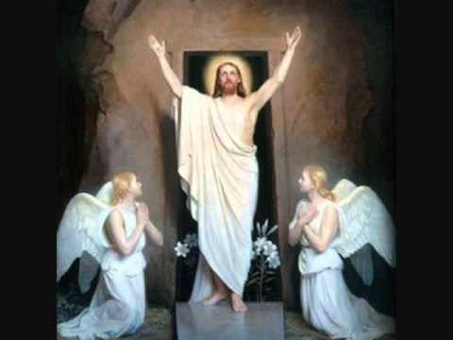
Look at the Easter images. Write down any questions you may have about these images.
Watch the clip of Palm Sunday.
Discuss the mood of the crowd, Disciples, Pharisees and Jesus. Draw an example of each and write phrases around your images to explain how they would have been feeling.

