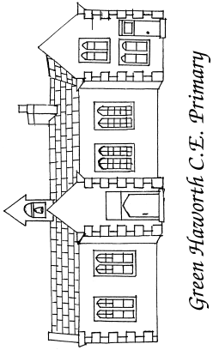

The education we offer is to enable young people to have not only the knowledge but also the attitudes, values and characteristics that will enable them to flourish in an ever-changing and demanding world. The education we offer goes beyond the purely academic. It must enable our young people to discover their unique place in the world, their God-given purpose; to realise their potential in the knowledge that the world is a poorer place without them.

“Be strong and courageous. Do not be afraid; do not be discouraged, for the Lord your God will be with you wherever you go.” Joshua 1:9

Calculations Policy

This policy contains the key procedures that are to be taught throughout the school. It has been written to ensure consistency and progression throughout the school. We are aiming to get each child to show fluency, reasoning and problem solving skills from EYFS – Year 6.

- Although the main focus of this policy is showing the core Concrete, Pictorial and Abstract ways of solving Maths problems, it is important to recognise that the ability to calculate mentally lies at the heart of numeracy.
- Mental calculation is not at the exclusion of written recording and should be seen as complementary to and not as separate from it. In every written method there is an element of mental processing.
- Written recording both helps children to clarify their thinking and supports and extends the development of more fluent and sophisticated mental strategies.
- Children are encouraged to use the most efficient method for them, making sure they use ones they have a clear understanding of.
- The long-term aim is for children to be able to select an efficient method of their choice that is appropriate for a given task. They should do this by always asking themselves:

- ‘Do I need to use manipulatives to help me?’

- 'Can I do this using drawings or jottings?'

- 'Do I need to use a written method?'

- 'Can I do this in my head?'

Stem sentences are in red, these are to help children embed their learning.

Addition
Vocab: add, plus, more than, total, sum of,
Bar model, part-part-whole, number line, tens frame, base 10, place value counters, missing numbers,
STEM sentences | Concrete (can we MAKE it?) |  | Pictorial (can we draw it?) |  | Abstract (can we write the calculation?)
___________ is a whole, ___________ is a part, __________ is a part.  There are ______ in total. | 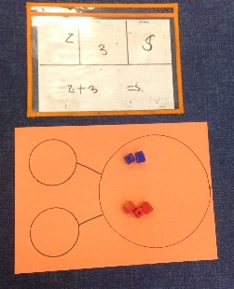  Use cubes, numicon and others to add two numbers together.  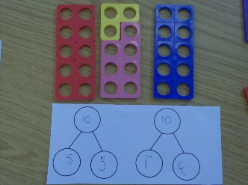  Use numicon and cubes to show number bonds. |  | 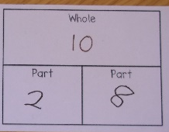  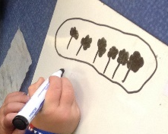  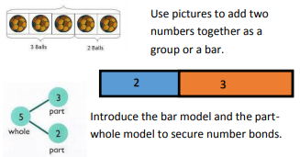 |  | 5 + 5 = 10  5 is a part, 5 is a part, the whole is ten.  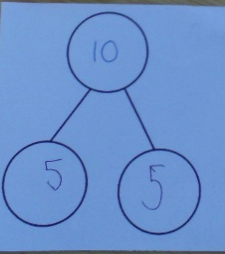
First… Then… Now…  E.g. First there were 4 children on the bus, then 3 children got on, Now there are 7 children on the bus.  (this will help with the inverse relationship and missing number) | 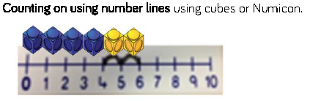 |  | A bar model which encourages the children to count on rather than count all.  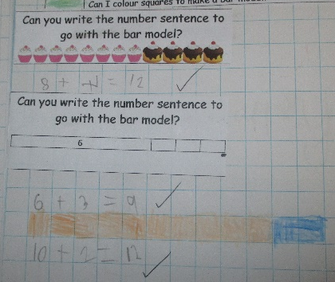 |  | 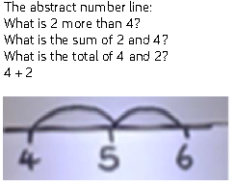
I need ____ to make ten. I have ____ left over. 10 + ___ is _____. | 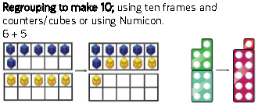 |  | 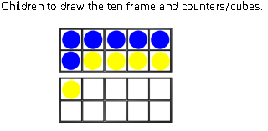 |  | 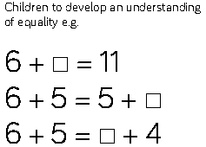
 | TO + O using base 10. Continue to develop understanding of partitioning and place value.  41 + 8  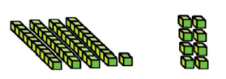 |  | 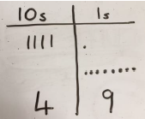  Children to represent base 10 e.g. lines for tens and dots for ones. |  | 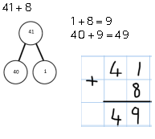
 | TO + O using base 10. Continue to develop understanding of partitioning and place value.  36 + 25  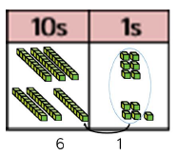  36  +25  _ |  | Children to represent the base 10 or place value counters, in a place value chart  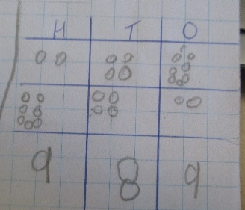v |  | 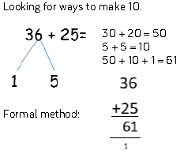
 | Conceptual variation; different ways to ask children to solve 21 + 34
 | 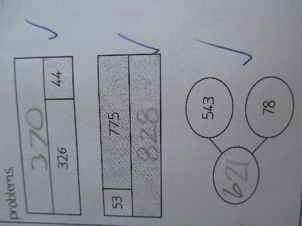 | Word problems:  In year 3, there are 21 children and in year 4, there are 34 children.  How many children in total?  21 + 34 = 55. Prove it |  | 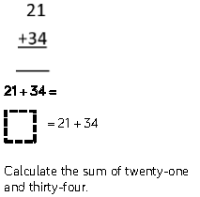 |  | 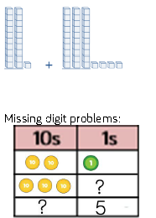
Subtraction
Vocab: take away, less than, the difference, subtract, minus, fewer, decrease, exchange
STEM sentences | Concrete |  | Pictorial |  | Abstract
First… Then… Now…  e.g. First there were 4 children in the car, then 1 child got out, Now there are 3 children in the car. | Physically taking away objects from a whole (tens frame, numicon, cubes etc…)  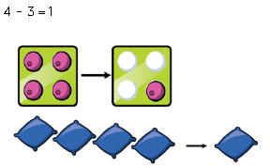 |  | Children to draw the concrete resources they are using and cross out the correct amount. The bar model can also be used.  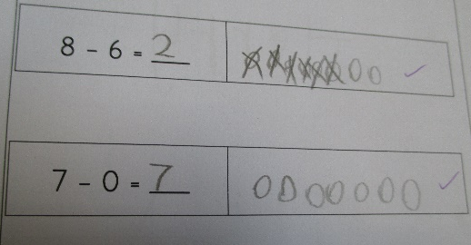 |  | 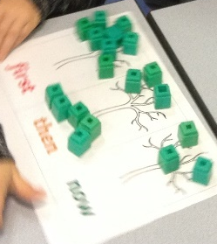  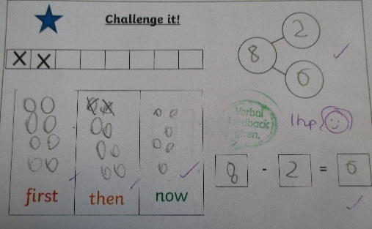
The whole is ____.  The part we are taking away is ______.  Start on ______ and count back ____. | Counting back (using number lines or tracks)  6-2=  Children start at 6 and count back 2  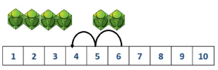 |  | Children to represent what they see pictorially e.g.  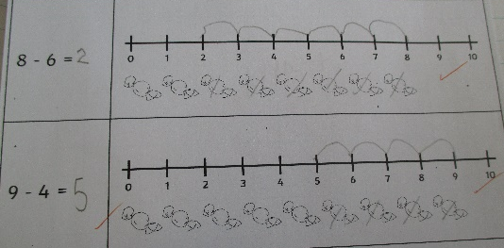 |  | Children to represent the calculation on a number line or number track and show their jumps. Encourage children to use an empty number line  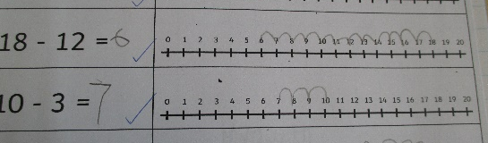
 | Finding the difference (using cubes, Numicon or other objects can also be used).  Calculate the difference between 8 and 5. |  | Children to draw the cubes/other concrete objects which they have used or use the bar model to illustrate what they need to calculate. |  | Find the difference between 8 and 5.  8 – 5, the difference is  Children to explore why  9 – 6 = 8 – 5 = 7 – 4 = have the same difference.
 |  |  | Children to present the ten frame pictorially and discuss what they did to make 10. |  | When children are confident they can draw this themselves.  Remind them to show order and uniform to help them.
 | Column method using base 10 or place value counters.  48-7 |  | Children to represent the base 10 pictorially.  35 – 23 =  draw the 3 tens and 5 ones  cross out the ones  cross out the tens  look how much remains |  | Encourage children to use mental strategies
 | Column method using base 10 or place value counters and having to exchange.  41 – 26  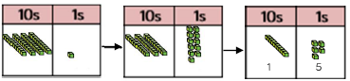  41 Here 1 ten has been Answer  exchanged for 10 ones |  | Represent the place value counters pictorially; remembering to show what has been exchanged.  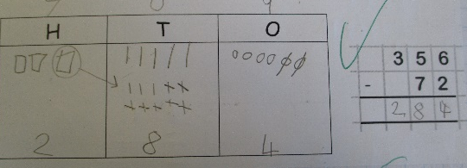 |  | Formal column method. Children must understand what has happened when they have crossed out digits.  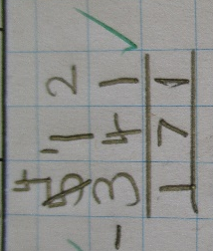
 | Conceptual variation; different ways to ask children to solve 391 - 186
 |  | Raj spent £391, Timmy spent £186.  How much more did Raj spend?  Calculate the difference between 391 and 186. |  | = 391 – 186  What is 186 less than 391? |  | Missing digit calculations

Multiplication
Vocab: double, times, multiplied by, the product of, groups of, lots of, equal groups, exchange
STEM sentences | Concrete |  | Pictorial |  | Abstract
We are counting in multiples of ____ so we count every ____.  There are ____ in each group. There are ____ groups. We have to add ____ _____ times. | Repeated grouping/repeated addition  7 × 2  2 + 2 + 2 + 2 + 2 + 2 + 2 =  There are 7 equal groups, with 2 in each group.  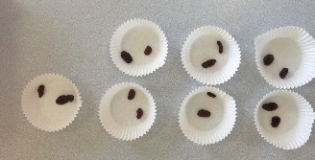  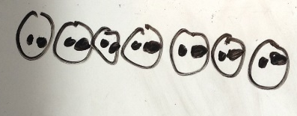 |  | Children to represent the practical resources in a picture and use a bar model.  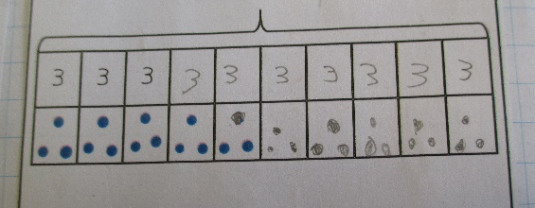 |  | 3 × 4 = 12  4 + 4 + 4 = 12
____ lots of ____ is the same as ____ lots of ____. | Use arrays to illustrate commutativity  counters and other objects can also be used.  2 × 5 = 5 × 2 |  | Children to represent the arrays pictorially.  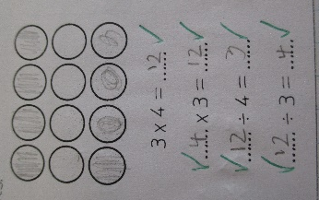 |  | Children to be able to use an array to write a range of calculations e.g.  - 10 = 2 × 5  - 5 × 2 = 10  - 2 + 2 + 2 + 2 + 2 = 10  - 10 = 5 + 5
____ can be partitioned into ____ and _____.  ____ lots of ___ ones is ____.  ____ lots of ____ tens is ____.  ____ ones add ____ tens is ____. | To first introduce the grid method, use Base 10 before moving towards a more compact method.  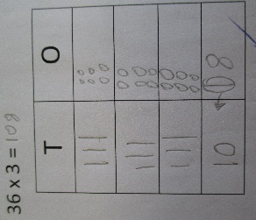  36 x 3 =  Make 36 on each row, there are 3 rows.  Add up each column, starting with the ones and exchange if needed.  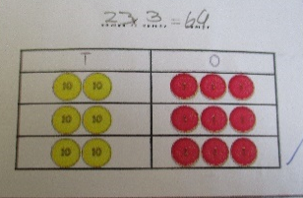  Move on to Place Value Counters to show how we are finding groups of a number. We are multiplying by 3 so need 3 rows. |  | Children can represent the work they have done with place value counters in a way that they understand. They can draw the counters, using colours to show different amounts or just use circles in the different columns to show their thinking as shown below.  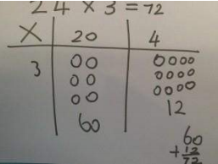 |  | Start with multiplying by one digit numbers and showing the clear addition alongside the grid.  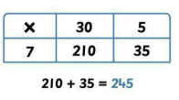  Moving forward, multiply by a 2 digit number showing the different rows within the grid method.  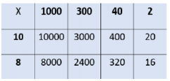
____ ones times ____ ones is ___ ones.  ____ ones times ____ tens is ____ tens. Because we are multiplying by ten, we need to add in a zero as a place value holder.  We cannot have more than one digit in any place value column, so we need to exchange ___ ones as ____ ten | Formal column method with place value counters  (base 10 can also be used.)  32 x 3  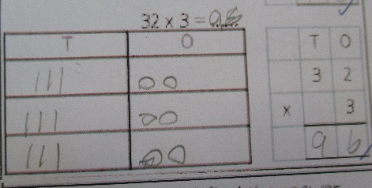 |  | Children to represent the base 10 or place value counters pictorially.  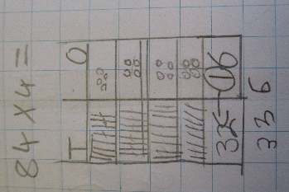 |  | Formal Written Method  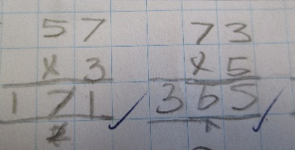
When children start to multiply 3d × 3d and 4d × 2d etc…, they should be confident with the abstract:

To get 744 children have solved 6 × 124.

To get 2480 they have solved 20 × 124.
 | Conceptual variation; different ways to ask children to solve 23 x 6
 |  | Mae had to swim 23 lengths, 6 times a week. How many lengths did she swim in one week?  With the counters prove that 23 x 6 = 138 |  | Find the product of 6 and 23  6 × 23 = __  __ = 6 × 23 |  | What is the calculation?  What is the product?
Division
Vocab: share, group, divide, divided by, half, divisor, dividend, quotient, remainder, exchange
STEM sentences | Concrete |  | Pictorial |  | Abstract
____ shared equally between ____ is _____ | Sharing a range of objects  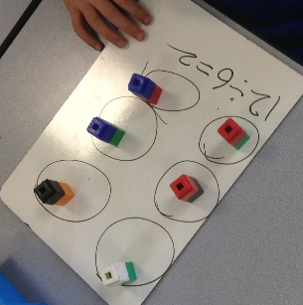  12 ÷ 2 =  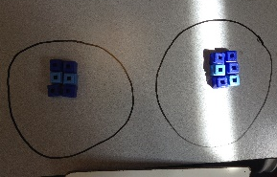 |  | Represent the sharing pictorially |  | 6 ÷ 2 = 3  Children should also be encouraged to use their 2 times tables facts.
  6
  3 | 3
 | Sharing – using concrete methods |  | 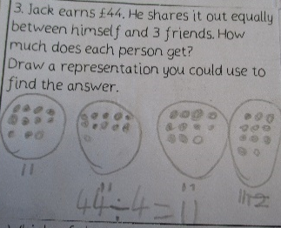  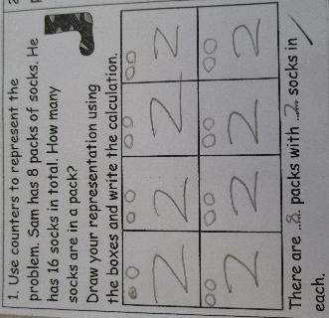  We move on to use formal jottings to help us solve the division. These can be in the form of sharing circles (squares!) |  | 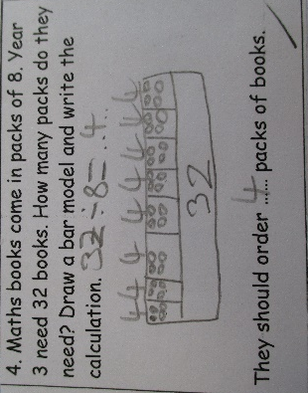  Children can use a bar model to help represent the division.
In division, we start from the largest place value column. We start from the right.  ___ is __ tens and ___ ones. ____ tens divided by ____ is ____. _____ ones divided by _____ is _____. ____ add ____ is _____. | Sharing using place value counters.  42 ÷ 3 = 14 |  | Children to represent the place value counters pictorially.  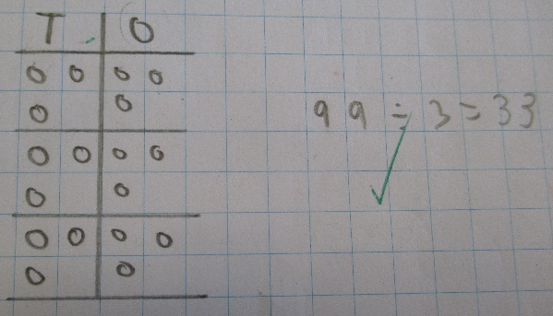 |  | Children to be able to make sense of the place value counters and write calculations to show the process.  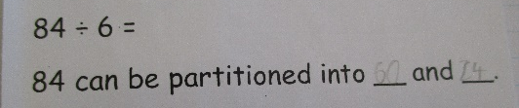  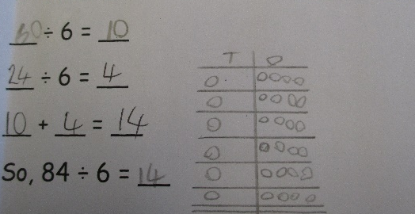
 | Short division using place value counters to group.  615 ÷ 5  1. Make 615 with place value counters.  2. How many groups of 5 hundreds can you make with 6 hundred counters?  3. Exchange 1 hundred for 10 tens.  4. How many groups of 5 tens can you make with 11 ten counters?  5. Exchange 1 ten for 10 ones.  6. How many groups of 5 ones can you make with 15 ones? |  | Represent the Place Value counters pictorially |  | Children to do the calculation using short division scaffold
Long division using place value counters
2544 ÷ 12
 | Conceptual variation; different ways to ask children to solve 615 ÷ 5
 | Using the part whole model below, how can you divide 615 by 5 without using short division? | I have £615 and share it equally between 5 bank accounts. How much will be in each bank account?  615 pupils need to be put into 5 groups. How many will be in each group? |  | 615 ÷ 5 = __  __ = 615 ÷ 5 |  | What is the calculation?  What is the answer?

